Lab Task 3
Abdul Rehman Hassan
04072313030

ScreenShots:
Step 1:
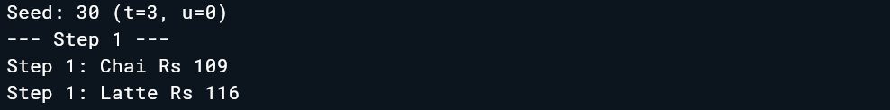

Step 2:

Step 3:
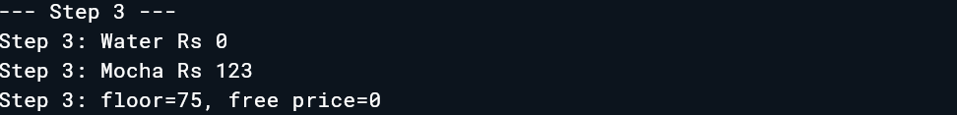

Step 4:
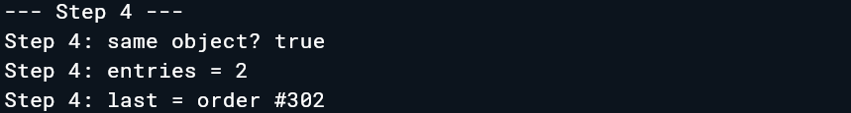

Step 5:
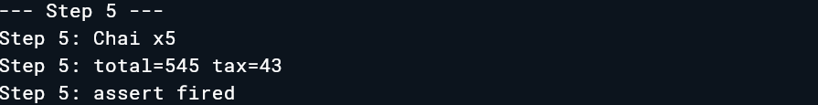

Step 5:
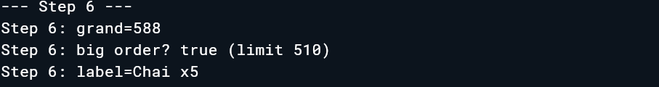

Step 6:
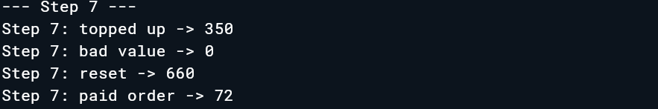

Step 8:
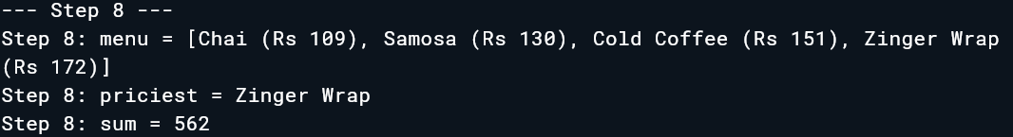

Step 9:

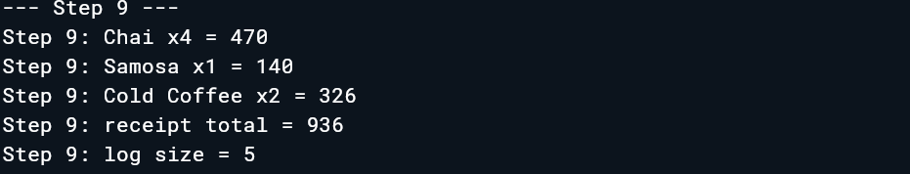

Step 10:
